[Ε007Τ]
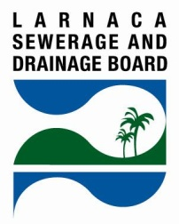
LARNACA SEWERAGE AND DRAINAGE BOARD (LSDB)

CONNECTION OF A RESIDENCE TO THE SEWERAGE SYSTEM

How to connect a residence to the Sewerage System?

In accordance with the Larnaca Sewerage and Drainage By-laws the following steps are required:

- Assign the preparation of the plan drawings in which the private sewerage system must be shown, to an Architect or a Civil Engineer who must be a registered member of the Cyprus Scientific and Technical Chamber.

- Submit an application form to the LSDB for the construction of the private sewerage system. The application form should include a copy of the title deed/s of the owner/s or if the applicant is a tenant the tenancy agreement, two sets of plan drawings, two sets of original topographical plans, a copy of the building permit (if any) and a copy of the Water Board Invoice.

- After the license for the construction of the private system is issued, the owner or tenant shall assign the construction of the private sewerage system in accordance with the approved drawings to a private contractor.

- The owner or tenant is responsible to notify the LSDB Technicians, in order to inspect the construction of the private sewerage system and to issue the final consent for the private sewerage system to be connected with the public sewerage system. The private contractor is responsible for connecting the private sewerage system to the public system.

Further information regarding the connection of a property to the public sewerage system is available on the LSDB leaflets and website www.lsdb.or.cy

